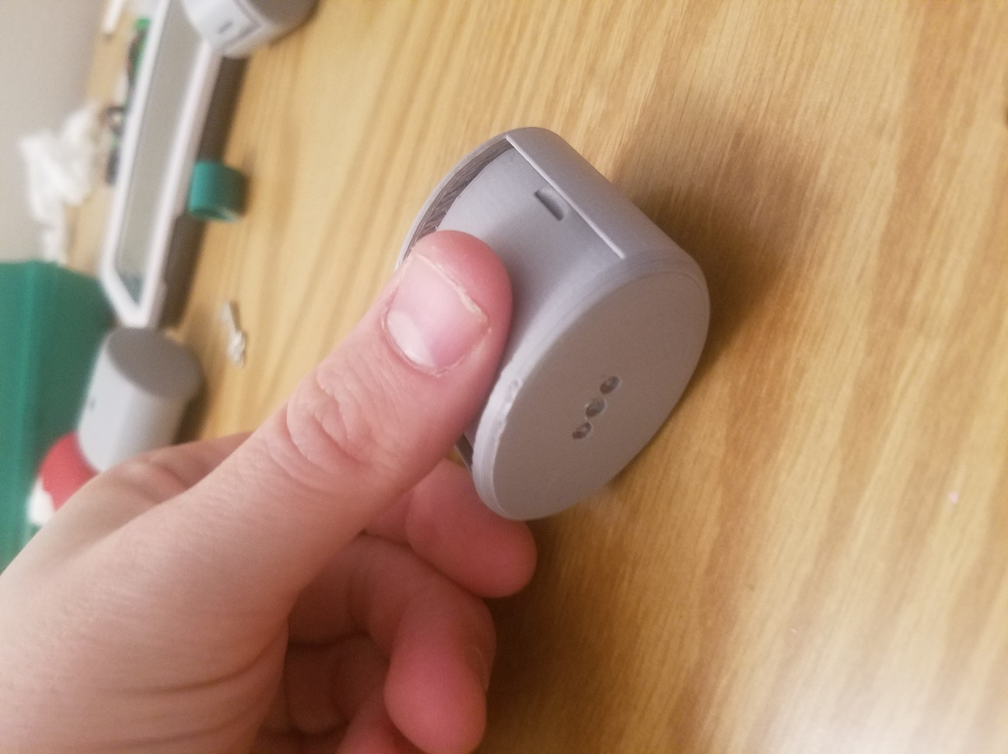**Velcro Design 1 (left):** This case was designed to be held together by Velcro between the top and bottom pieces. The width of two layers of Velcro was guessed at 0.25”, but this proved to be roughly 0.15” too large, as indicated by the fact that top is not flush with the top of the outer casing.

Separation was to be achieved by inserting fingernails into the slits on either side of the top. However, 0.3” was not nearly wide enough (see thumb for scale) and the depth of 0.1” (bottom) was also too shallow.

Finally, the 3 LEDs were intended to be places in a row, but this design was later revised.

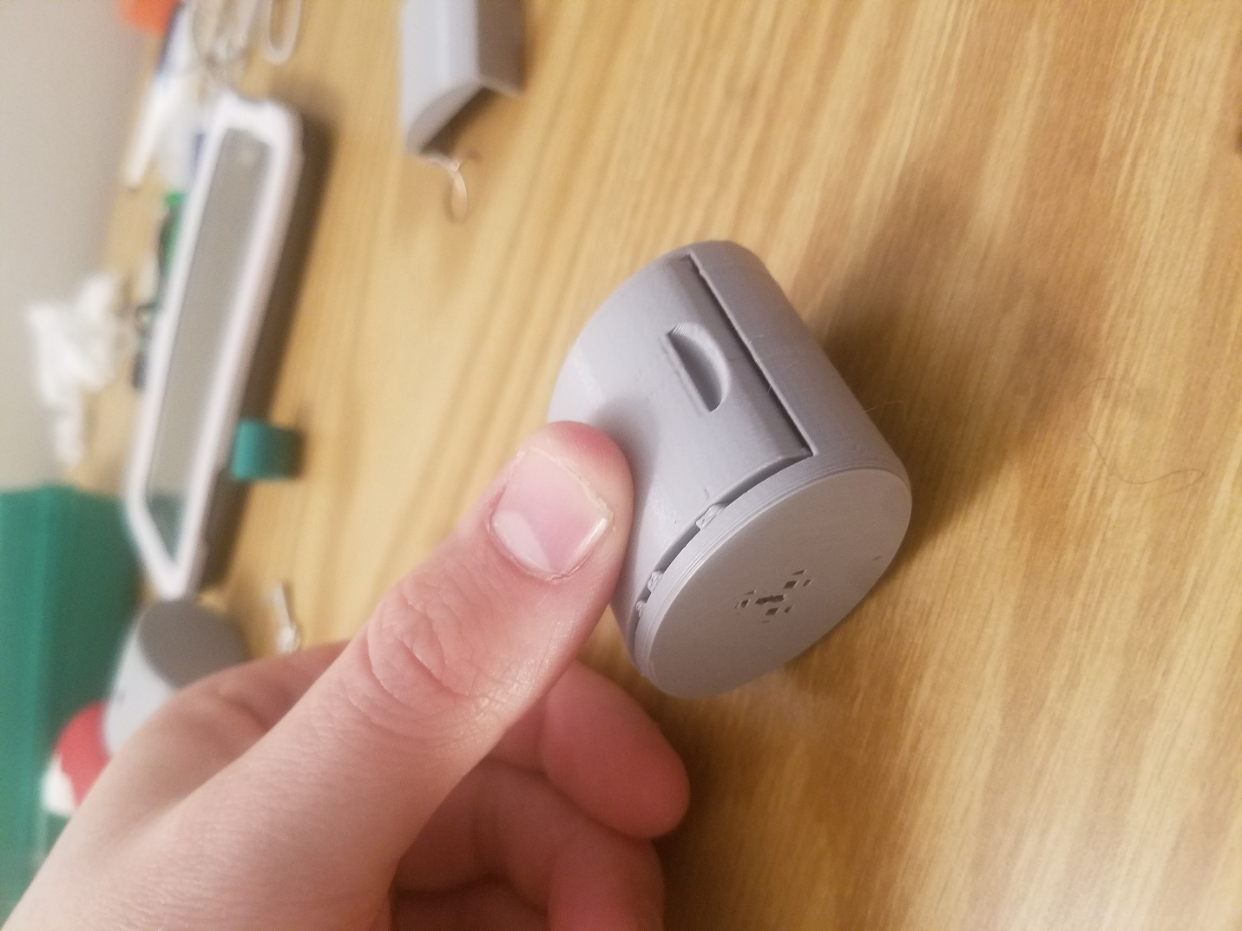**Velcro Design 2 (right):** Same as the above, but the width of strips of Velcro was adjusted so that the top would be flush with the top of the outer casing.

The nail indents were doubled in width to 0.6” and the depth was increased to 0.15”, making the indents comfortable to grip with most fingers.

Next, the top was made wider to accommodate the increased depth of the fingernail indents.

Finally, the configuration of the 3 LEDs was changed, but this did not print correctly. This was fixed in future generations.

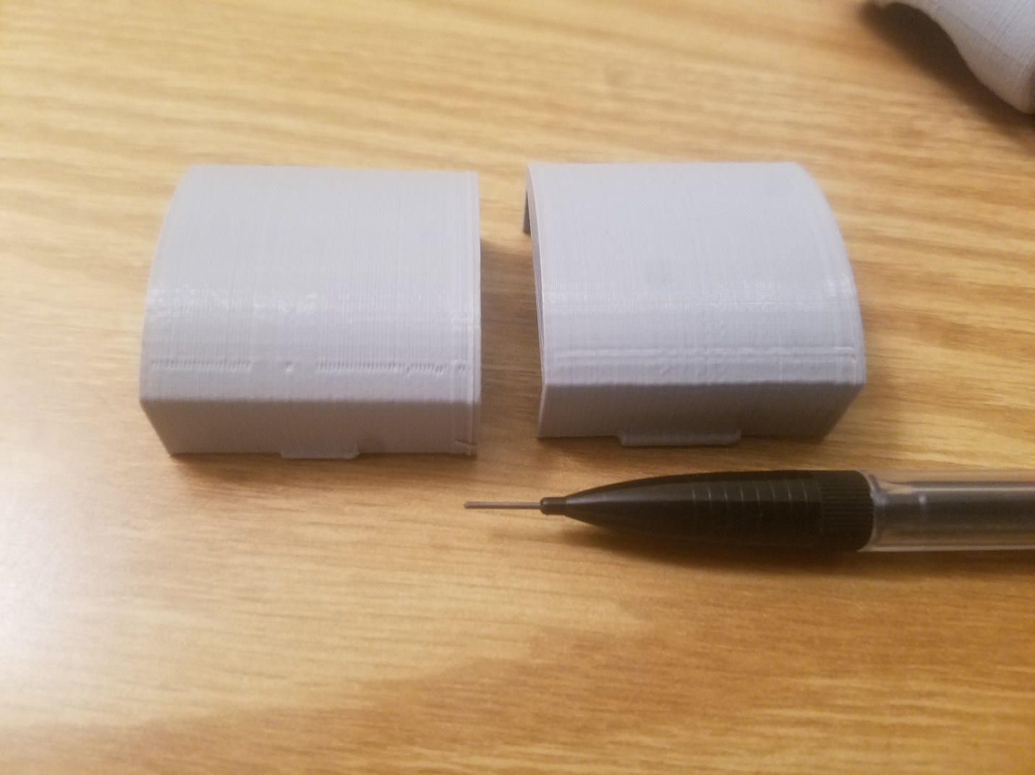**Clip Design 1 (left) and 2 (right):**

The clip design is very similar to the Velcro, with the exception of the fastening method. On the left, there is a 0.3”x0.03”x0.03” protrusion on either side of the top, with a corresponding (but slightly larger) indent on either side of the bottom. This was too loose, and so in generation 2, the protrusion was adjusted to 0.5”x0.05”x0.05”. This fits tightly into the larger holes on the bottom of the housing, making the top removable, but difficult to remove. Both protrusions possess a 0.03” fillet to increase structural integrity. 0.7mm lead is shown for scale.

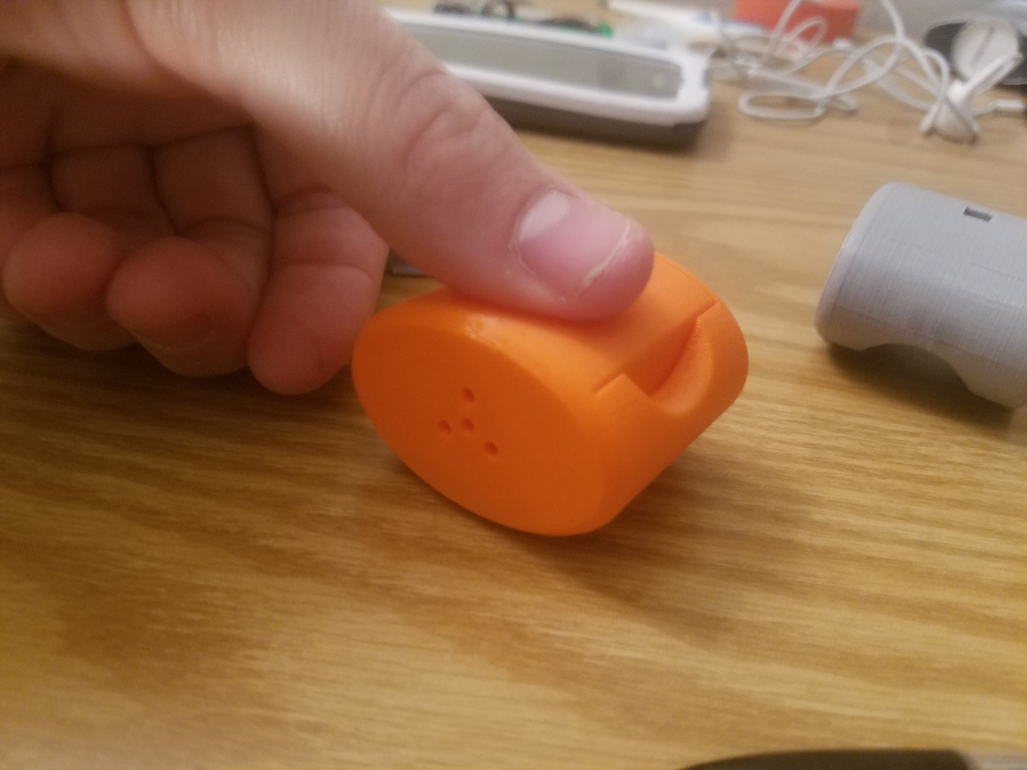**3D Printer Settings for Clip Design 2:**

As is shown in this image, the bottom contains 1 holes for the 3 signal wires of the 3 LEDs on the front (outside) and 1 central hole for the common ground wires of the LEDs, placing them in a circular pattern on the face of the flashlight. The bottom has a semicircular 0.8” diameter hole cut in either side, 0.05” above the indentation for the clips protruding from the top. These holes allow the user to pinch the sides of the top together, thereby removing the protrusions from their holes and allowing the top to be removed. The thumb, shown for scale, was the appropriate width for such protrusions.

The remaining question is what 3D printer settings allow sufficiently easy bending of the top piece to remove the protrusions from the holes in the bottom, without jeopardizing the structural integrity of the casing. It was determined that wall width (0.4 mm vs. 0.8 mm) played a much bigger role in flexibility and integrity than infill. The 0.4 mm wall width top can easily be removed by pinching the sides of the top and pulling, whereas the 0.8 mm wall width top requires an inordinate amount of force (or the use of a screwdriver to pry it open) to remove the top. In the end, the choice between these two is somewhat arbitrary, but I am leaning toward the 0.8 mm wall width in the hope that it will be able to survive a fall from any height due to its relatively low terminal velocity.